



ADMINISTRATIVE SUPPORT TEAM
(255)
STATE 2021

Production:
Job 1: Memorandum __________ (100 points)
Job 2: Itinerary __________ (100 points)
Job 3: Database Address List __________ (100 points)
Job 4: Registration Form __________ (100 points)
TOTAL POINTS __________ (400 points)

Test Time: 90 minutes

GENERAL INSTRUCTIONS

- Check that this test booklet contains Jobs 1-4.

- Correct all errors. Copy is graded on production standards.

- In places you normally use your reference initials, use your team’s number. Your name or initials should not appear on any work your team submits. Key your team’s number and job number in the footer in the lower right corner of all work submitted unless specified otherwise.

- If you finish before the end of the testing time, notify the proctor. Time may be a factor in determining a winner when there is a tie score.

- When turning in your contest, the jobs should be arranged in numeric order. Use your time wisely. You have ninety (90) minutes to complete this test.

- Save all work with your team number on the flash drive provided by the contest administrator.

Production Standards (when specified):
0 errors 100% of assigned point value of each document
1 error 90% of assigned point value of each document
2 errors 70% of assigned point value of each document
3 errors 50% of assigned point value of each document
4 or more errors 0% of assigned point value of each document

TEAM INSTRUCTIONS
You are part of the Administrative Support Team for Digital Solutions, 700 Morse Road, Suite 201, Columbus, OH 43214. Your team has been given the task of creating documents for use at the office. Be sure to use the Style & Reference Manual as a guide in preparing the documents.

Job 1: Memorandum (100 points)
Memorandum
Top Margin: 1"
Side Margins: 1"

MEMORANDUM

TO: Julie Smith, Harvey Rosen, Tom Carlson, Roger Meyer, and Edna Renick

FROM: Nancy Wells, CEO

DATE: (Current Date)

SUBJECT: Flexible Working Schedule

We will be implementing for the FY2021 a new flexible working schedule. This schedule will allow the employees in your department to flex their time at the office and at home. The new flexible schedule will be determined by the following qualifications at the discretion and approval of each department head:

• On time to work
• Two consecutive positive evaluations of job performance
• No letter of reprimand in employee folder
• High-quality Internet connection
• Not to exceed more than five days out of the office each week

This new flexible schedule will be in place July 1st. Make sure to meet with each employee in your department to develop a plan for the schedule when they work at home and the days they will work in the office.
Team ID #

Team ID# Job #

Job 2: Itinerary (100 points)
Itinerary
Top Margin: 1"
Side Margins: 1"

ITINERARY
Nancy Wells
July 2-4, 2021

Friday, July 2
2:25 p.m. Depart John Glenn Columbus International Airport (CMH) Southwest Airlines Flight 727 (non-stop).
5:05 p.m. Arrive in Palm Springs International Airport (PSP).
5:30 p.m. Uber XL to Palm Springs Golf Resort.
6:00 p.m. Dinner reception with the Board of Directors in the Arnold Palmer Suite.
Saturday, July 3
8:00 a.m. Breakfast meeting with James Woods, Board Chair, Arnold Palmer Suite.
9 a.m. BoardSource training with Board of Directors, 2nd floor Tiger Woods Suite.
Noon Luncheon with Google Executives.
2:00 p.m. Digital Solutions Board of Directors 2022 Strategic Planning.
5:00 p.m. 18-hole round of golf on Palm Springs Golf Course.
7:00 p.m. BBQ Dinner Palm Springs Golf Clubhouse.
Sunday July 4
7:00 a.m. Uber XL to Palm Springs International Airport (PSP).
9:30 a.m. Leave Palm Springs International Airport (PSP) on Southwest Airlines Flight 869 (non-stop).
1:10 p.m. Arrive at John Glenn Columbus International Airport (CMH).

Team ID# Job #
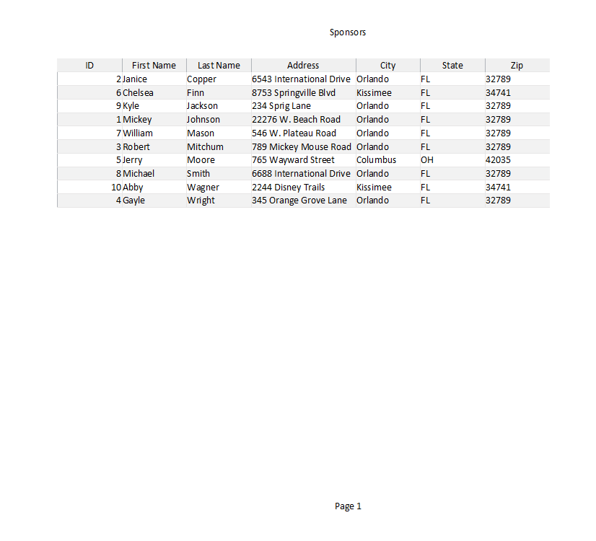
Job 3: Database Address List (100 points)
MUST BE LANDSCAPE ORIENTATION
Note to Grader: Below is all of the data that should be in the table above. The table above is missing some of the columns for easier grading.
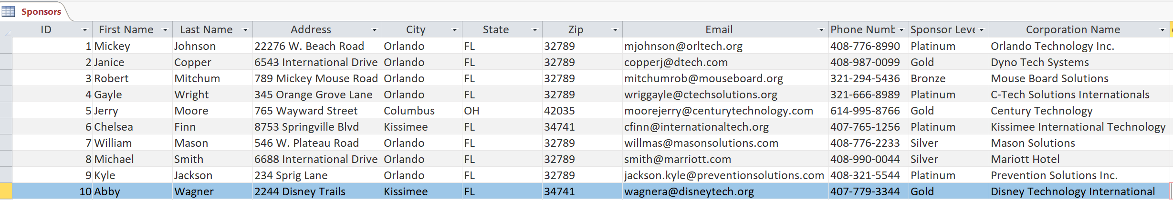

Job 4 Registration Form (100 points)
Registration forms can vary from the key, as long as all the information is included and the 2 ¼ pt. border is used. Score according to: Design of Form, Creativity, Contains all Parts, Border

Digital Solutions Vendor Registration

First Name: _________________________________________
Last Name: _________________________________________

Address: ____________________________________________

City: _________________ State: ______________________ Zip: ______________

Email Address: __________________________________

Company Name: ________________________________ Company Website: ______________
Vendor Booth- Full Size $10,000 Medium Size $5,000 Small Size $3,000
Payment Type: Cash______________ Check____________ Credit Card _________

Technology Needs at Booth: Yes or No (circle one)
If YES, what is needed? _________________________________________________

Submit form to erenick@digitalsolutions.org

Team ID# Job #

